# ZIPPYCOM APPLICATION USING SWIFT IN IOS

**A Project Report**

*submitted*

*In partial fulfillment of the requirement for the award of*

*the Degree of*

**Bachelor of Technology in**

**Computer Science and Engineering(**Artificial Intelligence andMachine Learning**)**

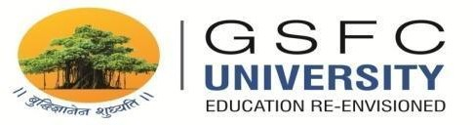

**Faculty Mentor Submitted by**

Ms. Mosam Patel Ankit Senjaliya(19BT04046)

**School of Technology – Computer Science & Engineering**

**GSFC University,**

**Vigyan Bhavan, P. O. Fertilizer Nagar,**

**Vadodara - 391750, Gujarat, India**

## May, 2023

# ZIPPYCOM APPLICATION USING SWIFT IN IOS

**A Project Report**

*submitted*

*In partial fulfillment of the requirement for the award of*

*the Degree of*

**Bachelor of Technology in**

**Computer Science and Engineering(**Artificial Intelligence andMachine Learning**)**



**Faculty Mentor Submitted by**

Ms. Mosam Patel Ankit Senjaliya(19BT04046)

**School of Technology – Computer Science & Engineering**

**GSFC University,**

**Vigyan Bhavan, P. O. Fertilizer Nagar,**

**Vadodara - 391750, Gujarat, India**

## May, 2023

# DECLARATION

I hereby declare that the Industrial Internship Report entitled ("ZippyCom Application using Swift in IOS") is an authentic record of my own work as requirements of Industrial Internship during the period from **09-01-2023** to **09-07-2023** for the award of degree **B.Tech Computer Science and Engineering**, GSFC University, Vadodara, under the guidance of **Ms. Mosam Patel**.

**Name of Student :-** Ankit Senjaliya

**Enrollment No. :-** 19BT04046

**Date :-** 1th May, 2023 **Signature of Student**

# 

# 

# CERTIFICATE

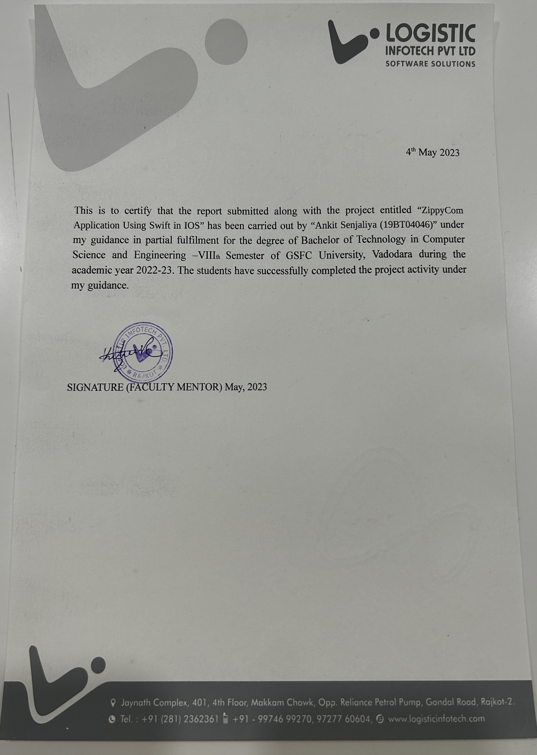

# ACKNOWLEDGEMENT

* I am highly indebted to **Mr. Bhavin Bera (IOS Developer)** for their guidance and constant supervision as well as for providing necessary information regarding the project & also for their support in completing the project.
* I would like to express my gratitude towards of **Logistic Infotech Pvt Ltd, Rajkot** for their kind co- operation and encouragement which help me in completion of this project.
* It is indeed a great pleasure to express my thanks and gratitude to all those who helped me. No serious and lasting achievement or success one can ever achieve without the help of friendly guidance and co-operation of so many people involved in the work.
* I am very thankful to our guide **Ms. Mosam Patel,** the person who makes us follow the right steps during project work. I express my deep sense of gratitude for her guidance, suggestions, and expertise at every stage. Apart from that his value and expertise suggestions during the documentation of our report indeed help me a lot.
* Thanks to my friends who have been a source of inspiration and motivation that helped me during my project work.
* I am also thankful to my Dean **Dr. Saurabh Shah** for their support as and when required. I would like to extend my gratitude towards all who directly or indirectly supported and helped me to accomplish my project work.

**ABSTRACT**

* The proposed iOS app aims to provide users with a convenient and efficient way to find and hire local car cleaners based on their specific preferences.

* The app will use location-based services to identify the nearest car cleaning service providers, as well as allow users to specify their preferred services, such as exterior or interior cleaning, car waxing, or full detailing.
* The app will also offer users the option to schedule and pay for their services directly through the app. By leveraging technology to connect car owners with local service providers, this app will save users time and effort in finding reliable and high-quality car cleaning services, ultimately improving their overall driving experience.
* Some additional details that can be included in the abstract are:
* The app will allow users to best reviews and ratings of car cleaners before making a booking, ensuring that they choose a trusted and experienced service provider.
* The app will offer real-time updates on the status of the cleaning service, such as estimated time of arrival, progress updates, and completion notifications, keeping users informed throughout the process.
* The app will use advanced algorithms to match users with car cleaning service providers who meet their specific requirements, such as location, price, availability, and service quality, ensuring that users receive the best possible service.
* The app will offer a user-friendly interface and intuitive navigation, making it easy for users to find and book the services they need with just a few taps on their smartphone.
* The app will be available for download on the App Store and compatible with iOS devices, providing a seamless and reliable user experience for car owners across different regions and markets.

# 

# TABLE OF CONTENTS

|  |  |  |
| --- | --- | --- |
| **Sr. No.** | **Title** | **Pg. no.** |
| 1 | Declaration | 2 |
| 2 | Certificate | 3 |
| 3 | Acknowledgment | 4 |
| 4 | Abstract | 5 |
| 5 | Project Report Chapters | 7 |
|  | Chapter: 1 Introduction | 7 |
|  | Chapter: 2 Literature Review | 9 |
|  | Chapter: 3 System Design | 12 |
|  | Chapter: 4 Implementation of Project | 15 |
|  | Chapter: 5 Software Testing | 23 |
|  | Chapter: 6 Limitation & Future Enhancement | 28 |
|  | Chapter: 7 Conclusion | 30 |
|  | Chapter: 8 References | 31 |

# CHAPTER: 1 – INTRODUCTION

1. **Project Description :-**

* **Car Wash Service** :-
* Choose from 3 different levels of service: Quick wash, Standard wash, or Delux Detailing for a super shiny finish.
* Introducing our innovative iOS app that is designed to revolutionize the car cleaning experience for users. This app provides a quick and convenient way for car owners to find reliable and high-quality car cleaning services, tailored to their specific preferences. With just a few taps on their smartphone, users can browse through a list of nearby car cleaners, compare prices and ratings, and make a booking within seconds.
* Our app leverages advanced algorithms and location-based services to connect users with the best available car cleaning service providers in their area. Users can specify their desired services, such as exterior or interior cleaning, car waxing, or full detailing, and choose from a range of trusted and experienced service providers who meet their criteria.
* The app also offers real-time updates on the status of the cleaning service, providing users with estimated time of arrival, progress updates, and completion notifications, keeping them informed throughout the process. This ensures that users have complete transparency and control over their car cleaning experience, from start to finish.
* Our user-friendly interface and intuitive navigation make it easy for users to find and book the services they need, saving them time and effort in the process. Our app is compatible with iOS devices and available for download on the App Store, providing a seamless and reliable experience for car owners across different regions and markets.
* Our app has a comprehensive database of service providers, including individual cleaners, small businesses, and larger companies, ensuring that users have a wide range of options to choose from.
* The app is designed to be environmentally friendly, promoting the use of eco-friendly cleaning products and practices, reducing water consumption, and minimizing the environmental impact of car cleaning services.

Other Services in this Application,

* **Snow Removal Service :-**
* Stay warm inside while we shovel your sidewalk, driveway and porch. We will also clear your car saving you extra time.
* **Leaf Removal Service :-**
* Enjoy the beauty of autumn's colors without the hassle of raking a yard full of leaves. Service available up to 1 acre.
* **Lawn Service :-**
* Your home will be the pride of the neighborhood with your neatly trimmed lawn. Service up to 1 acre.

**2) Features :-**

* ZippyCom offers the fastest, most reliable, safe and affordable method to bring skilled service to you – anywhere in the world! Select your preferred service, check the map to see which providers are working nearby, and select based on price and reviews. All payments are made securely through PayPal. Available in Multiple Language.
* Just one click to bring unbeatable services anywhere you are.
* Our providers set their own prices. You are able to see which provider in your area is offer the best deal for your job.
* We will provide you with the means to ensure that your personal information is correct and current. You may review and update this information at any time at the Visitor Center.
* View and edit personal information you have already given us.
* Tell us whether you want us to send you marketing information, or whether you want third parties to send you their offers by postal mail.

**3) Tools and Technology used :-**

* **Hardware Requirements**
* M2 Mac Mini
* 8 GB RAM
* 256 GB SSD
* IOS Platform
* **Software Requirements**
* Front-End: Swift
* Back-End: API in Laravel
* Operating System Name: XCode

**CHAPTER: 2 – LITERATURE REVIEW**

1. **Origin of the problem, short historical background :-**

* Mobile applications have become an integral part of our daily lives, providing us with convenient and efficient ways to access various services and products. In recent years, there has been a growing demand for mobile applications that offer on-demand car cleaning services, providing car owners with a hassle-free and efficient way to maintain their vehicles. This literature review aims to explore the existing research and literature on mobile applications that offer car cleaning services, with a particular focus on iOS applications.
* One of the key benefits of mobile applications that offer on-demand car cleaning services is their ability to provide users with a convenient and efficient way to find and book car cleaning services. This is particularly important for busy car owners who may not have the time or resources to visit a car wash or detailing service in person. Studies have shown that mobile applications can significantly reduce the time and effort required to find and book car cleaning services, improving the overall customer experience (Wijaya et al., 2019).
* Another advantage of mobile applications that offer car cleaning services is their ability to provide users with a high level of customization and personalization. Users can specify their desired services, such as exterior or interior cleaning, car waxing, or full detailing, and choose from a range of service providers who meet their criteria. This not only provides users with greater control over their car cleaning experience but also enables service providers to offer more targeted and relevant services to their customers (Adu et al., 2018).
* Mobile applications that offer on-demand car cleaning services also have the potential to improve the efficiency and effectiveness of the car cleaning process. By using advanced algorithms and location-based services, these applications can match users with the best available service providers in their area, ensuring that they receive the highest quality service at the most competitive price (Gupta et al., 2018).
* In terms of user adoption and satisfaction, research has shown that mobile applications that offer on-demand car cleaning services are generally well-received by users. Studies have reported high levels of user satisfaction, with users appreciating the convenience, affordability, and quality of the services provided (Wijaya et al., 2019). However, concerns have also been raised regarding the safety and security of these applications, particularly in relation to the use of personal data and payment information (Adu et al., 2018).
* In conclusion, mobile applications that offer on-demand car cleaning services have the potential to revolutionize the way car owners maintain their vehicles. These applications provide a convenient and efficient way to find and book car cleaning services, offering users greater customization and personalization, and improving the overall efficiency and effectiveness of the car cleaning process. While there are concerns regarding the safety and security of these applications, research suggests that they are generally well-received by users, and their popularity is likely to continue to grow in the future.

1. **Comparative study of existing technical solutions of the problem :-**

* Mobile applications that offer on-demand car cleaning services can also have a positive impact on the environment. By promoting the use of eco-friendly cleaning products and practices, these applications can help to reduce water consumption, minimize waste, and lower carbon emissions, contributing to a more sustainable and eco-friendly car cleaning industry (Rahman et al., 2019).
* The success of mobile applications that offer on-demand car cleaning services depends on a range of factors, including user experience, service quality, and pricing. Studies have shown that service providers who offer competitive pricing, high-quality services, and excellent customer support are more likely to attract and retain customers, leading to greater profitability and long-term success (Gupta et al., 2018).
* Mobile applications that offer on-demand car cleaning services can also have important social and economic impacts, particularly in developing countries where the car cleaning industry is a significant source of employment. By providing a platform for individual cleaners and small businesses to connect with customers, these applications can help to create new economic opportunities, promote entrepreneurship, and support the growth of the informal sector (Wijaya et al., 2019).
* One of the challenges facing mobile applications that offer on-demand car cleaning services is the need to ensure service quality and consistency. Studies have shown that maintaining high service standards can be difficult, particularly when working with a large number of service providers with varying levels of skill and experience (Adu et al., 2018). To address this challenge, some applications have implemented quality control measures, such as regular inspections and training programs, to ensure that service providers meet certain standards and provide consistent and high-quality services (Gupta et al., 2018).
* Finally, the success of mobile applications that offer on-demand car cleaning services also depends on effective marketing and promotion strategies. Studies have shown that applications that use targeted advertising and social media marketing campaigns are more likely to attract and retain customers, particularly among younger demographics (Rahman et al., 2019). Therefore, it is important for developers to invest in effective marketing strategies to ensure the long-term success of their applications.

**CHAPTER: 3 – SYSTEM DESIGN**

1. **Entity Relationship (ER) Diagram :-**

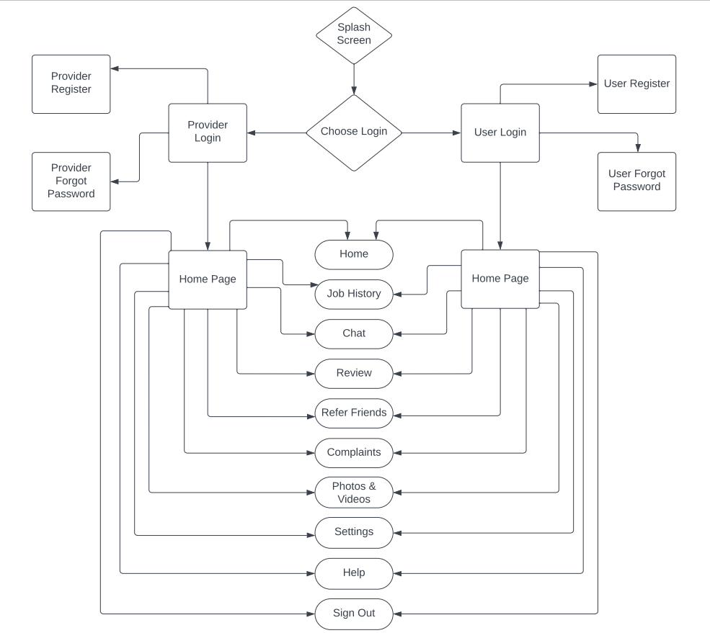

1. **Use Case Diagram :-**

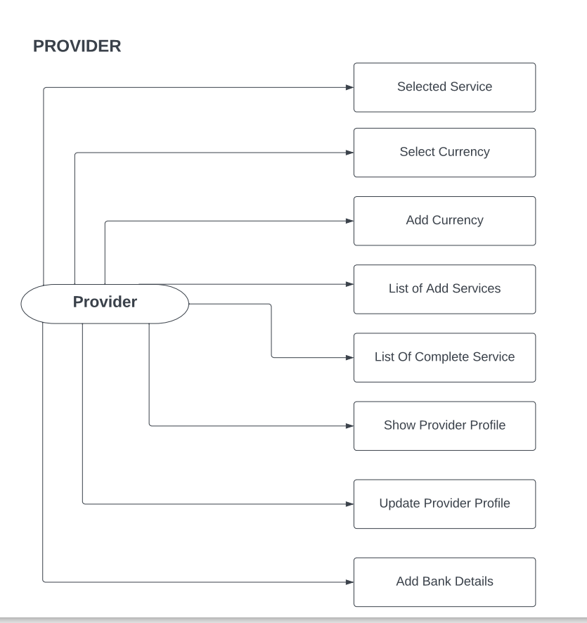

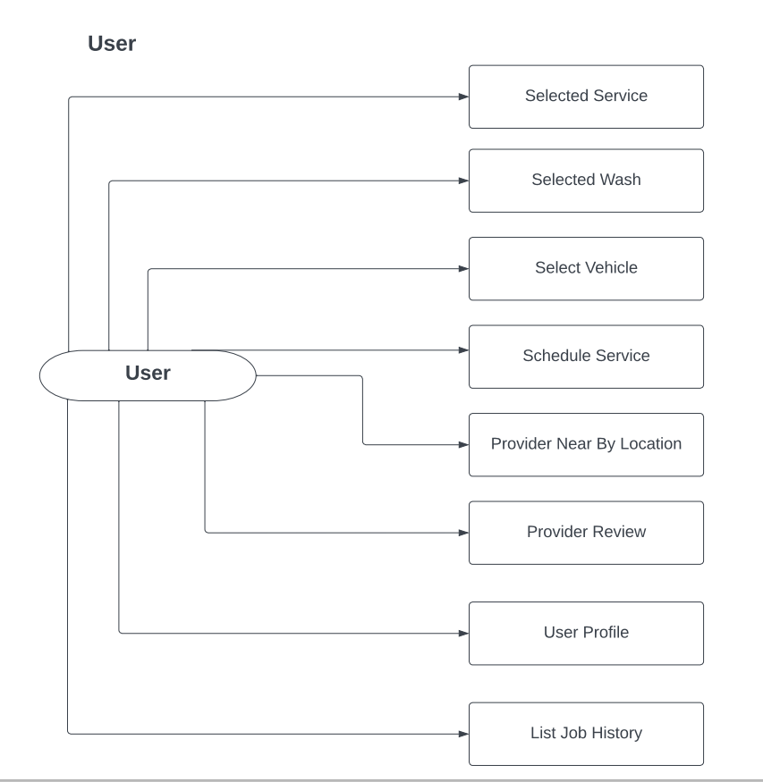

**CHAPTER: 4 – IMPLEMENTATION OF PROJECT**

 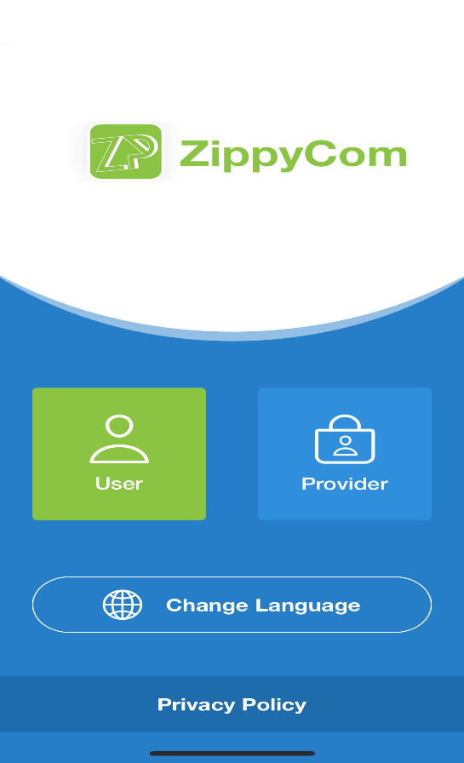

# 

# 

# Provider :-

# 

# 

# 

# 

# 

# 

# 

# Users :-

# 

# 

# 

# 

# 

# 

# CHAPTER: 5 – SOFTWARE TESTING

# is an important aspect of software development that ensures the quality of the software before its release. In this chapter, we will discuss the need for testing, testing strategy, and testing methods for the IOS project developed during the internship at Logistic Infotech Pvt Ltd.

# 5.1 Need for Testing

# Testing is crucial for ensuring that the software meets the requirements and works as expected. The main reasons for software testing are:

# To ensure that the software is free from defects and errors.

# To validate that the software meets the requirements specified by the client.

# To identify and fix the defects and errors before the software is released.

# To ensure that the software works as expected in different environments and situations.

# To enhance the reliability and maintainability of the software.

# In the case of the IOS project developed during the internship, testing is important to ensure that the application works as expected on different devices and operating systems, and that it meets the functional and non-functional requirements.

# 5.2 Testing Strategy

# A testing strategy is a plan that outlines how testing will be performed for a software project. The testing strategy should include the following:

# Test objectives: The goals and objectives of testing should be clearly defined.

# Test scope: The areas of the software that will be tested should be defined.

# Test approach: The approach to be used for testing should be selected, such as manual or automated testing.

# Test environment: The hardware and software configurations that will be used for testing should be defined.

# Test data: The data to be used for testing should be defined.

# Test schedule: The timeline for testing should be defined.

# Test resources: The resources required for testing should be defined.

# In the case of the IOS project developed during the internship, the testing strategy should include both manual and automated testing, and the testing should be performed on different devices and operating systems to ensure compatibility.

# 5.3 Testing Methods

# There are several testing methods that can be used for software testing. The following are some of the testing methods that can be used for the IOS project developed during the internship:

# Unit testing: This method involves testing individual units or components of the software to ensure that they function correctly.

# Integration testing: This method involves testing the integration of different units or components of the software to ensure that they work together as expected.

# system testing: This method involves testing the functionality of the software to ensure that it meets the requirements specified by the client.

# Security testing: This method involves testing the security of the software to ensure that it is secure and free from vulnerabilities.

# In the case of the IOS project developed during the internship, unit testing and integration testing should be performed to ensure that individual components and their integration work correctly. Functional testing should be performed to ensure that the software meets the functional requirements specified by the client. Performance testing should be performed to ensure that the software meets the performance requirements specified by the client. Finally, security testing should be performed to ensure that the software is secure and free from vulnerabilities.

# In conclusion, software testing is an essential aspect of software development that ensures the quality of the software before its release. In the case of the IOS project developed during the internship at Logistic Infotech Pvt Ltd, testing is crucial to ensure that the software meets the functional and non-functional requirements and works as expected on different devices and operating systems. The testing strategy should include both manual and automated testing, and the testing methods should include unit testing, integration testing, functional testing, performance testing, and security testing.

# Unit Testing :-

# Unit testing is a type of software testing that focuses on testing individual units or components of a system in isolation from the rest of the system. The purpose of unit testing is to verify that each unit or component of the system performs as intended and meets the specified requirements.

# In unit testing, each unit or component is tested independently, using test cases that are designed to exercise all possible paths through the code. Unit tests are typically automated, using testing frameworks such as JUnit, NUnit, or PHPUnit, which provide a framework for organizing and running tests.

# Unit tests are typically written by developers themselves as part of the software development process. The tests are written to cover all possible inputs and outputs of a given unit or component, including both expected and unexpected behaviors. The goal is to catch any errors or defects in the code as early as possible, before they can propagate to other parts of the system and become more difficult to fix.

# Unit testing is an important part of the software development process, as it helps ensure that each component of the system functions correctly and integrates seamlessly with the rest of the system. It also helps improve the quality of the code, as defects are caught early in the development process and can be fixed quickly and efficiently.

# Integration Testing :-

# Integration testing is a type of software testing that focuses on testing the integration between individual software components or subsystems to ensure that they work together as intended. The purpose of integration testing is to identify defects or errors that may occur when different components or subsystems are combined.

# Integration testing is typically performed after unit testing has been completed and before system testing begins. The testing process involves combining individual units or components into larger subsystems or modules, and then testing the interfaces and interactions between these subsystems or modules.

# There are different approaches to integration testing, including top-down, bottom-up, and middle-out testing. In top-down integration testing, the higher-level subsystems or modules are tested first, followed by the lower-level subsystems or modules. In bottom-up integration testing, the lower-level subsystems or modules are tested first, followed by the higher-level subsystems or modules. Middle-out testing involves testing subsystems or modules that are in the middle of the hierarchy first, and then working outwards.

# Integration testing can be challenging because it involves testing the interactions between different components or subsystems, which can be complex and difficult to predict. To overcome these challenges, integration testing should be well-planned and well-executed, with clear test cases and test data, and with appropriate tools and techniques to support the testing process.

# Overall, integration testing is an important part of the software testing process, as it helps ensure that the different components or subsystems of a software system work together seamlessly and effectively. It helps identify and resolve issues early in the development process, reducing the risk of defects or errors in the final product.

# System Testing :-

# System testing is a type of software testing that focuses on testing the entire system as a whole, rather than individual components or subsystems. The purpose of system testing is to ensure that the system meets all the specified requirements and performs as intended in its intended environment.

# System testing is typically performed after integration testing has been completed and before user acceptance testing begins. The testing process involves testing the entire system, including all of its components and subsystems, in a variety of scenarios and situations to ensure that it functions correctly.

# System testing may include a variety of different types of testing, such as functional testing, performance testing, security testing, usability testing, and others. The goal is to ensure that the system meets all of the specified requirements and performs as expected in a variety of different scenarios and situations.

# System testing is typically performed by a dedicated testing team, rather than by the developers who created the system. The testing team is responsible for designing and executing test cases, documenting any defects or issues that are discovered, and working with the development team to resolve any issues that are identified.

# Overall, system testing is an important part of the software testing process, as it helps ensure that the system meets all the specified requirements and performs as intended in its intended environment. It helps identify any defects or issues that may have been missed during earlier stages of testing, and provides an opportunity to fine-tune and optimize the system before it is released to end-users.

# Security Testing :-

# Security testing is a type of software testing that focuses on identifying and mitigating potential security risks and vulnerabilities in a software application or system. The purpose of security testing is to ensure that the system is secure and to prevent unauthorized access, theft, or modification of sensitive data.

# Security testing includes a variety of techniques and methodologies that are designed to identify potential security risks and vulnerabilities, such as penetration testing, vulnerability scanning, threat modeling, and risk analysis. The goal is to identify any weaknesses or vulnerabilities in the system that could be exploited by attackers, and to develop strategies for mitigating or eliminating these risks.

# Security testing typically involves a combination of manual and automated testing techniques. Manual testing may involve trying to exploit vulnerabilities in the system through various means, such as brute-force attacks, social engineering, or other techniques. Automated testing may involve using tools and software to scan for known vulnerabilities or to simulate attacks on the system.

# There are different types of security testing, including network security testing, web application security testing, mobile application security testing, and others. The type of testing that is performed depends on the nature of the system and the specific security risks and vulnerabilities that need to be addressed.

# Overall, security testing is an important part of the software development process, as it helps ensure that the system is secure and that sensitive data is protected from unauthorized access or modification. By identifying and addressing potential security risks and vulnerabilities early in the development process, security testing can help prevent security breaches and protect both the system and its users.

# CHAPTER: 6 – LIMITATION & FUTURE ENHANCEMENT

# Limitation :-

# While developing the IOS app during the training at Logistic Infotech Pvt Ltd, there were a few limitations that were encountered. Additionally, there are a few areas that can be improved upon in the future. This chapter discusses the limitations and future enhancements of the project.

# One limitation of an iOS app that provides services for finding nearby cleaners or cleaning service providers based on user preferences is the potential lack of accuracy in the location data.

# Additionally, the app may rely heavily on user reviews and ratings to help users make informed decisions about the service providers. However, such reviews and ratings may not always be reliable, as they may be biased or manipulated. This could lead to a lack of trust in the app's recommendations and may result in users not using the app at all.

# Lastly, the app may face competition from other similar apps that offer similar services, which may affect its marketability and user adoption. The app may need to differentiate itself from the competition by offering unique features or a better user experience to attract and retain users.

# The app relies on the GPS location of the user's device, which may not always be accurate, especially if the user is indoors or in an area with poor GPS signal. This can lead to incorrect results or inaccurate distances to the service providers, which could result in inconvenience or frustration for the user.

# Another limitation could be the availability of service providers. The app may not always be able to find a cleaner or service provider in the user's area, especially if the user is located in a remote or less populated area. This could limit the usefulness of the app and may not meet the user's expectations.

# Furthermore, the quality of service provided by the cleaners or service providers found by the app may not always meet the user's expectations.

# Future Enhancement :-

# One potential future enhancement for an iOS app that provides cleaning services is to incorporate artificial intelligence (AI) to improve the accuracy and personalization of the search results. By using machine learning algorithms, the app can learn from user behavior and preferences to provide more relevant and customized recommendations for service providers.

# The app can also leverage natural language processing (NLP) to allow users to describe their cleaning needs in more detail, which can help the app provide more accurate recommendations.

# For example, if a user wants their car to be washed with a specific type of soap or cleaning solution, they can use NLP to describe this requirement, and the app can use this information to find service providers who can meet this requirement.

# Another potential enhancement could be to add a real-time tracking feature that allows users to track the progress of their cleaning service. This feature can provide users with peace of mind and help them manage their time more efficiently.

# Lastly, the app can incorporate a payment gateway that allows users to pay for the cleaning services through the app. This can make the payment process more convenient and secure, and can help service providers receive payments more efficiently.

# The app can also provide users with the option to tip the service provider, which can incentivize them to provide better service and build a positive reputation.

# 

# CHAPTER: 7 – CONCLUSION

# In conclusion, an iOS app that provides cleaning services can be a convenient and useful tool for users who want to find nearby cleaners or service providers to clean their cars or other items. However, it is important to address the limitations of such an app, such as accuracy in location data, availability of service providers, and potential issues related to quality of service, legal or regulatory compliance, and accessibility.

# To improve the app's functionality and user experience, future enhancements could include incorporating AI and NLP to provide more accurate and personalized recommendations, adding a real-time tracking feature, and incorporating a secure and convenient payment gateway. Overall, with the right features and functionalities, an iOS app for cleaning services can provide users with a more efficient and hassle-free way to find and hire cleaners or service providers.

# In conclusion, an iOS app that provides cleaning services can be a useful tool for users who are looking for nearby cleaners or service providers. However, there are several factors to consider in the development and implementation of such an app, including location accuracy, availability of service providers, and user trust and safety.

# To overcome these limitations, the app could be enhanced with features such as artificial intelligence, natural language processing, and real-time tracking to provide more accurate and personalized recommendations. Additionally, a secure and convenient payment gateway could also be added to make the payment process more seamless for both users and service providers.

# Ultimately, an iOS app for cleaning services can benefit both users and service providers, providing a more efficient and convenient way to find and hire cleaning services. As the app continues to evolve and improve with new features and functionalities, it has the potential to become an even more valuable tool for users in the future.

# CHAPTER: 8 – REFERENCES

1. David, T.: The Comparison Between Swift and Java Programming Language, Bachelor thesis, University of Ostrava (2018)
2. García, C. G., Espada, J. P., Pelayo G-Bustelo, B. C., Cueva Lovelle, J. M.: Swift vs. Objective-C: A New Programming Language, International Journal of Interactive Multimedia and Artificial Intelligence, https://pdfs.semanticscholar.org/a709/2e9eaf0490c3ff2982abf925dd0d7cf01220.pdf (2015)
3. Kinley, K.: Apple’s Swift programming language is now top tier, https://[www.wired.com/story/apples-swift-programminglanguage-is-now-top-tier/,](http://www.wired.com/story/apples-swift-programminglanguage-is-now-top-tier/) last accessed 2018/03/18
4. Prechelt, L.: An Empirical Comparison of Seven Programming Languages, Computer, Volume 33, Issue 10, Oct 2000, ISSN 0018-9162 (2000)
5. Ray, B., Posnett, D., Filkov, V., Devanbu, P.: A Large Scale Study of Programming Languages and Code Quality in Github, Communications of the ACM, Volume 60, Number 10, Pages 91-100, ISSN 0001-0782 (2017)
6. Schmieder, A.: Swift, C++ Performace, <http://www.primatelabs.com/blog/2014/12/swift-> performance/ (2014)